**Questionnaire A Name:**

|  |  |  |  |
| --- | --- | --- | --- |
| **1: To start a fire, you need ...** | | | |
| ☐ | Oxygen (air) | ☐ | Fuel (e.g. wood) |
| ☐ | Heat | ☐ | All three |

|  |  |  |  |
| --- | --- | --- | --- |
| **2: Where is the flame of a candle at its hottest?** | | | |
| ☐ | In the yellow region | ☐ | In the blue region |
| ☐ | Directly above the wick | ☐ | A few centimeter above the flame |

|  |  |  |  |
| --- | --- | --- | --- |
| **3: Which color is not part of the rainbow?** | | | |
| ☐ | Yellow | ☐ | Red |
| ☐ | White | ☐ | Blue |

|  |  |  |  |
| --- | --- | --- | --- |
| **4: How does a printer produce different colors?** | | | |
| ☐ | The colors are already mixed in the cartridge | ☐ | Through tiny colored dots close together |
| ☐ | The printer mixes the colors itself | ☐ | The colors are mixed on the paper |

|  |  |  |  |
| --- | --- | --- | --- |
| **5: Order from largest to smallest according to size:** | | | |
| ☐ | Diameter of a hair > bacterium > virus | ☐ | Diameter of a hair > virus > bacterium |
| ☐ | Virus > Durchmesser eines Haares > bacterium | ☐ | Bacterium > diameter of a hair > virus |

|  |  |  |  |
| --- | --- | --- | --- |
| **6: If you turn a magnifying glass around and look through the other side, the image is...** | | | |
| ☐ | Smaller than before | ☐ | As big as before |
| ☐ | As bi gas before, but mirrored | ☐ | Smaller than before and mirrored |

|  |  |  |  |
| --- | --- | --- | --- |
| **7: At least how many lenses do you need for a microscope?** | | | |
| ☐ | 1 | ☐ | 3 |
| ☐ | 2 | ☐ | 4 |

**8. In the picture you can see a microscope. Connect the terms with the corresponding parts on the microscope. If you can think of more terms, label them.**

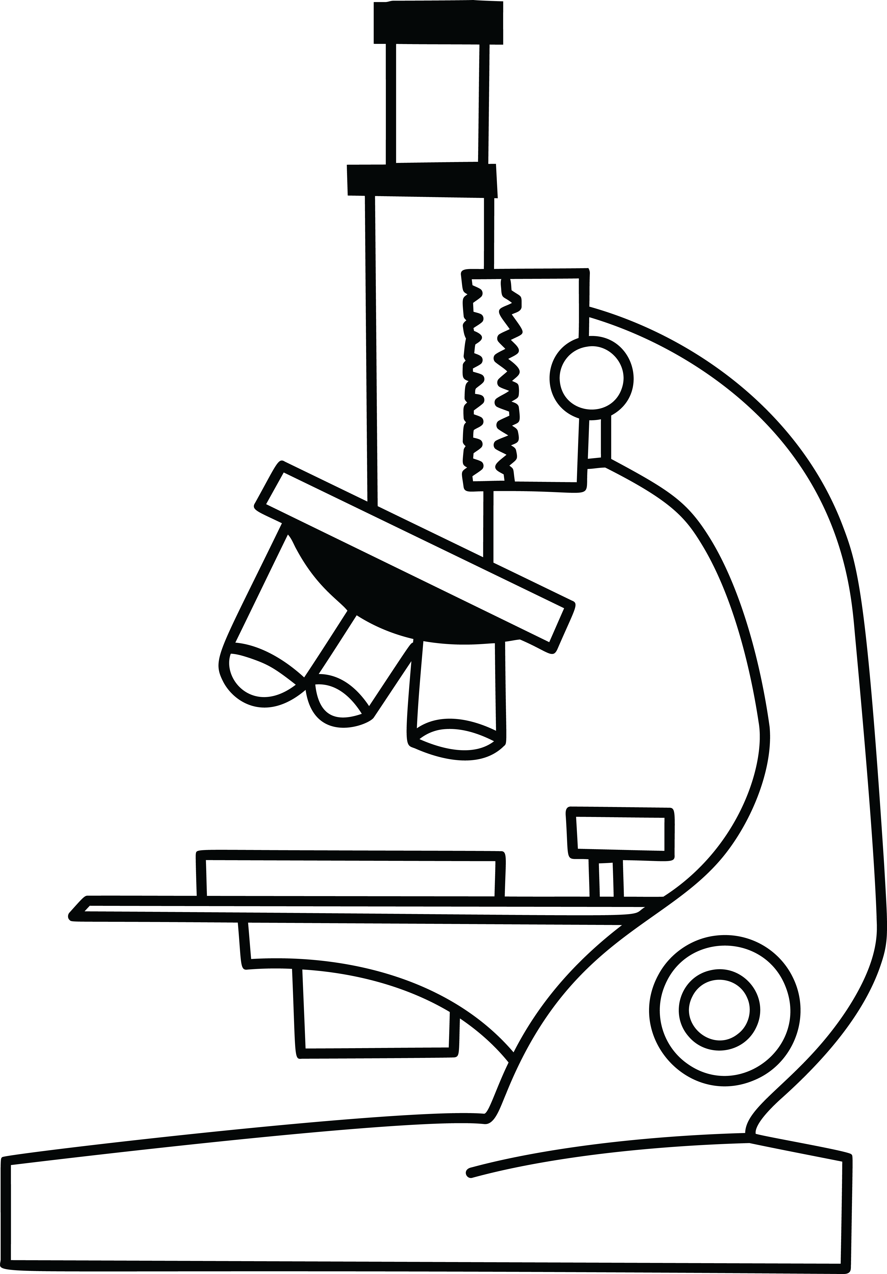

Objective

Light source

Ocular

Sample

|  |  |  |  |
| --- | --- | --- | --- |
| **9: What do you change, when you focus a microscope?** | | | |
| ☐ | The distance from the source to the sample | ☐ | The distance between the sample and the objective |
| ☐ | The distance between the ocular and the observer | ☐ | The light intensity |

|  |  |  |  |
| --- | --- | --- | --- |
| **10: When you look through a microscope, the image is ...** | | | |
| ☐ | Mirrored left/right | ☐ | Mirrored top/bottom |
| ☐ | Mirrored left/right and top/bottom | ☐ | Oriented the same as the original |

Draw the letter P as you would see it through a microscope:

P